Activity 5-1

Question 1
Evaluate the polynomial limits by direct substitution:
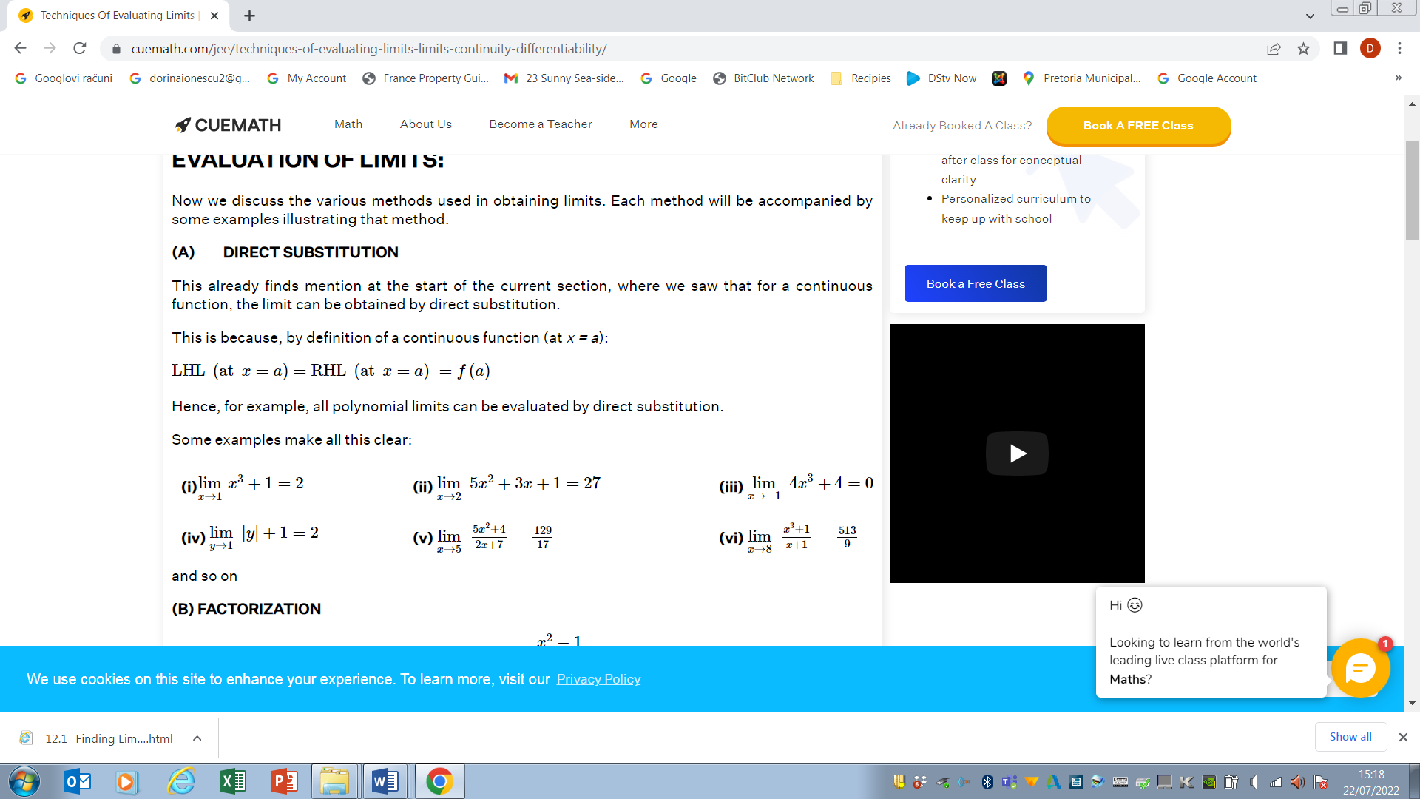
i.e. 1³+ 1=2

i.e. $5×2^{2}+3×2+1=27$

